# 1 Project

## 1.1 Goal

The goal of this project is to create a website that features Marvel characters and allows users to match with characters based off their personality traits. The website will be designed using the Agile methodology, ensuring an iterative and collaborative approach to software development of the Marvel brand, incorporating elements of the Marvel universe such as comic book graphics, superhero themes and vibrant color schemes. Regarding user experience, the website should be intuitive and easy to navigate, with a clear and organized layout. The personality tool should be engaging and interactive, with a user-friendly interface and clear results display. Ultimately, the website's style will reflect the fun and engaging nature of the Marvel Universe, while also providing high-quality user experience for users of all ages and backgrounds.

### 1.1.1 Style

The style of the Marvel Personality Matching website would be influenced by Agile software Trello which utilizes SCRUM methodologies.

### 1.1.2 Potential users

The users of the Marvel Personality Matching website would be fans of Marvel Universe, including comic book fans, movie fans, and fans of Marvel characters in general. These users can be of any age and come from a wide range of backgrounds and interests. They may use the website to learn more about Marvel characters, to discover which characters they are most like, or simply as a fun interactive way to engage with the Marvel universe.

## 1.2 Project Requirements

### 1.2.1

As a Marvel Fan, I want to be able to identify which of the 16 Meyer’s Briggs Personality Types I am, so that I can compare it to which Marvel character shares that same personality.

### 1.2.2

As a survey taker, I want to be able to be redirected if my results are inconclusive, so that I do not feel left out.

### 1.2.3

As a Marvel Fan, I want to respond to 25 questions, so that there is enough information to assess what Marvel personality I am.

### 1.2.4

As a Marvel Fan, I want there to be a minimum of 16 marvel superhero personality types, so that I know that my personality type is not limited.

### 1.2.5

As a fiction fan, I want there to be non-marvel character comparisons after receiving my results, so that I may know which other fictional characters share similar personalities.

### 1.2.6

As a Marvel Fan, I would like there to be a graphic of my personality, so that I can see what the Marvel character looks like.

### 1.2.7

As a Marvel fan, I want there to be an analysis of what percentage of each personality I am, so that I know what percentage of each Marvel character I am.

1.2.8

As a Marvel fan, I want to be able to take the personality test again in the future, so that I can see if my personality type changes over time.

1.2.9

As a Marvel fan, I want to be able to share my results with others, so that I can see if my friends also have marvel characters with the same personality as me.

## 1.3 Preliminary Design Description

After taking the survey the user will be given results which tells them which personality they fit best.

* The first character of the personality survey tells the user whether they are Introverted (I) or Extroverted (E).
* The second character of the personality survey tells the user whether they are sensing (S) or intuitive (N).
* The third character of the personality survey tells the user whether they are thinking (T) or feeling (F).
* The fourth character of the personality survey tells the user whether they are judging (J) or perceiving (P).

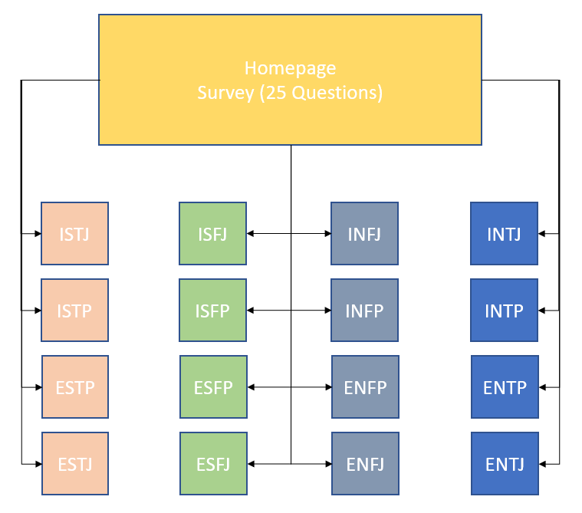

## 1.4 Preliminary Development Schedule

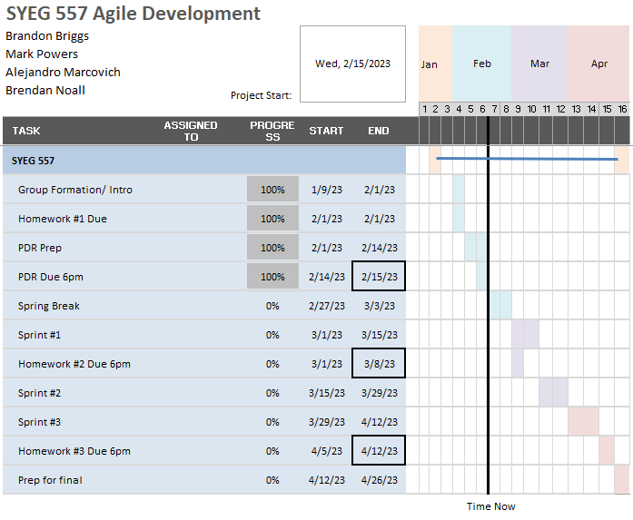

## 1.5 Development Tools

### 1.5.1 Trello

A collaboration tool that organizes your projects into boards. In one glance, Trello tells you what's being worked on, who's working on what, and where something is in a process.

### 1.5.2 LMU BUILD

A free web hosting and content management service for all faculty, staff, and current students at LMU.

### 1.5.3 WordPress

An open-source content management system (CMS) software used to build, modify, and maintain websites. In technical terms, WordPress is written in PHP and run on a MySQL or MariaDB database.

### 1.5.3 WhatsApp

Free chat used by 2 billion people in over 180 countries use WhatsApp to stay in touch with friends and family, anytime and anywhere.

#### 1.5.3.1

WhatsApp is a phone application utilized for mass-media communication.

#### 1.5.3.2

When the team does not meet on Wednesdays, they will be communicating with each other via WhatsApp when they need to communicate with team members that cannot be corroborated using Trello.